# 2020 MSA Project

Azure & Cloud Fundamentals

## The problems I meet

1. My blog starts too slow and with slow response.
2. I cannot search my blog on google, I have to jump back to my Azure each time before I edit it.
3. Spam, not so much but enough.
4. I can see the number of visits to my blog, the time of visit from Azure, but I cannot see what they visited and how long did they stay.

### Why I need plugins

Firstly, I am not a web engineer and I am not good at coding. Secondly, modularization of website functions is a trend. Finally, websites do not run efficiently at beginning.

## The type of plugins could solve my issues and the reasons

1. I need a plugin to boost its response. (e.g. speed up or boost website plugins)
2. Add my blog into research engine. (e.g. search engine spiders’ plugins)
3. Block spam. (e.g. anti-spam)
4. Provide site analysis so I can improve it. (e.g. analytics plugins)

## Plugin provider comparing and reasons

1. For search engine spiders’ plugins:

Yoast vs All in one (data end at 21.45 5/June/2020)

1. Five stars rating ratio:

Yoast five stars/total reviews: 25627/27180 94.29%

All in one five stars/total reviews: 783/898 87.19%

1. Active Installations:

Yoast: 5+ Million

All in one: 2+ Million

1. Strength:

Yoast: focus on let search engine find it efficiently.

All in one: as its name, wide functions.

Conclusion: I prefer Yoast finally, due to it is professional, high rating ratio and user number.

1. For anti-spam plugins:

CleanTalk vs Automattic (data end at 22.59 5/June/2020)

1. Five stars rating ratio:

CleanTalk five stars/total reviews: 1843/1987 92.75%

Automattic five stars/total reviews: 779/882 88.32%

1. Active Installations:

CleanTalk: 0.1+ Million

Automattic: 5+ Million

1. Strength:

CleanTalk: Highly professional, High adjustable filtering

Automattic: Simple and easy to use

Conclusion: I prefer Automattic, because of it is totally free, although it is not as professional as CleanTalk and the five stars rating ratio is lower than CleanTalk.

## Implemented plugins and its benefits

1. At the left top corner, there is a dashboard button. 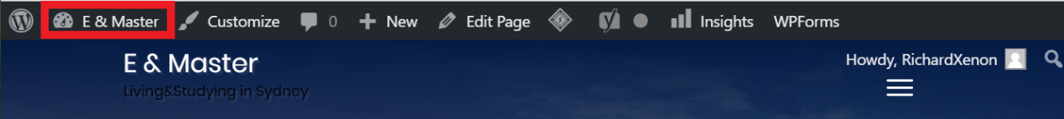

Figure Dashboard Button

1. You can see dashboard operation side, lots of operations, including “plugins”. No matter with “Add New” or “Installed Plugins”, the dashboard provides “search bar” to search what plugins you want. 社交网站的手机截图

   描述已自动生成

Figure Plugins Module and Search Bar

1. Just input key words to search, simply and easy. Here are two examples for searching plugins which I need.

Figure Search Anti-Spam Plugins

Figure Search making blog display in Search Engine Plugins

1. After installed plugins, do not forget to active plugins, otherwise, it will not work at all.

### The benefits of installing plugins

Plugins provide a solution for website owners, which is intuitive, concise, and even free. For example, when I cannot find my blog on Google, I can install a SEO to solve it. And setting what functions I need, what functions I can turn off.